**Name: Krishna Sampat**

**TE IT B3 1414109**

**WP EXP 8**

***Home Page:***

<!DOCTYPE html>

<html>

<head>

<style>

div {

background-color: white;

width: 1200px;

height: 400px;

padding: 25px;

border: 25px solid blue;

margin: 5px;

}

div1 {

width: 100px;

height: 100px;

background: red;

-webkit-transition: width 2s, height 2s, -webkit-transform 2s;

transition: width 2s, height 2s, transform 2s;

}

div1:hover {

width: 100px;

height: 100px;

-webkit-transform: rotate(180deg);

transform: rotate(360deg);

}

ul {

list-style-type: none;

margin: 0;

padding: 0;

overflow: hidden;

background-color: #333;

}

li {

float: left;

}

li a {

display: block;

color: white;

text-align: center;

padding: 14px 16px;

text-decoration: none;

}

li a:hover:not(.active) {

background-color: #111;

}

.active {

background-color: #4CAF50;

}

h3 {

color: white;

text-shadow: 1px 2px 2px black, 0 0 25px blue, 0 0 5px darkblue;

}

.button {

color: white;

padding: 10px 32px;

text-align: center;

text-decoration: none;

display: inline-block;

font-size: 16px;

margin: 4px 2px;

-webkit-transition-duration: 0.4s;

transition-duration: 0.4s;

cursor: pointer;

}

.button2 {

background-color: white;

color: black;

border: 2px solid #FF1493;

}

.button2:hover {

background-color: #0000FF;

color: white;

}

body{

background-image: url("l.jpg");

background-size: 1450px 800px;

background-repeat: no-repeat;

}

</style>

<script src="109js.js"></script>

</head>

<body>

<h2><div1><img src="logo.jpg" height=100px width=100px align="left"></div1>Indian Railway Reservation</h2>

<br><br><br>

<div>

<ul>

<li><a href="file:///C:/Users/User/Desktop/train/109.html">Home</a></li>

<li><a href="file:///C:/Users/User/Desktop/train/about.html">About us</a></li>

<li><a href="file:///C:/Users/User/Desktop/train/contact.html">Contact us</a></li>

<li><a href="file:///C:/Users/User/Desktop/train/complaint.html">Register a Complaint</a></li>

</ul>

<br>

<h3><font size="6">Login</h3></font>

<form name="form" onsubmit="return validate109()" method="post">

<font size="5">User Id :

<input type="text" name="userid">

<br><br>

Password :

<input type="password" name="pwd1">

<br><br>

<button type="submit" formaction="file:///C:/Users/User/Desktop/train/tt.html" >Login!</button>

</font>

<br><br>

<font size="5">

<a href="file:///C:/Users/User/Desktop/train/Registeration.html" >Sign up!</font></a>

</div>

</body>

</html>

***Validation of home page:***

function validate109(){

if(form.userid.value == "") {

alert("Error: User Id cannot be blank!");

form.userid.focus();

return false;

}

re = /^\w+$/;

if(!re.test(form.userid.value)) {

alert("Error: User Id must contain only letters, numbers and underscores!");

form.userid.focus();

return false;

}

if(form.pwd1.value != "" && form.pwd1.value == form.pwd2.value) {

if(form.pwd1.value.length < 6) {

alert("Error: Password must contain at least six characters!");

form.pwd1.focus();

return false;

}

if(form.pwd1.value == form.username.value) {

alert("Error: Password must be different from Username!");

form.pwd1.focus();

return false;

}

re = /[0-9]/;

if(!re.test(form.pwd1.value)) {

alert("Error: password must contain at least one number (0-9)!");

form.pwd1.focus();

return false;

}

re = /[a-z]/;

if(!re.test(form.pwd1.value)) {

alert("Error: password must contain at least one lowercase letter (a-z)!");

form.pwd1.focus();

return false;

}

re = /[A-Z]/;

if(!re.test(form.pwd1.value)) {

alert("Error: password must contain at least one uppercase letter (A-Z)!");

form.pwd1.focus();

return false;

}

} else {

alert("Error: Please check that you've entered and confirmed your password!");

form.pwd1.focus();

return false;

}

alert("You entered a valid password: " + form.pwd1.value);

return true;

}

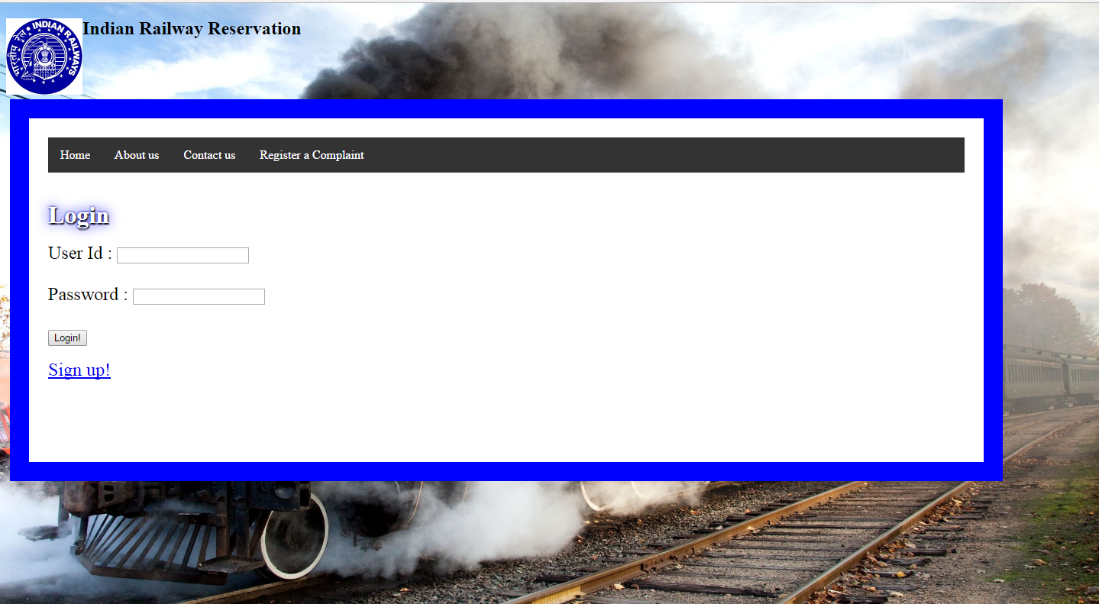

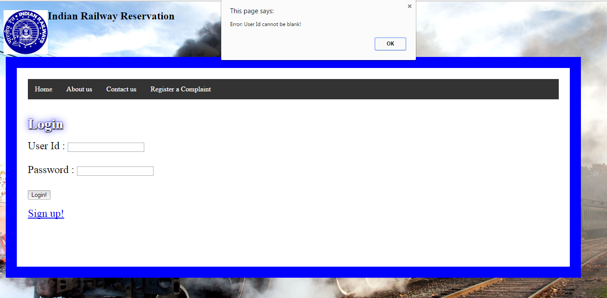

***About us page***

<html>

<head>

<title>About us</title>

<style>

ul {

list-style-type: none;

margin: 0;

padding: 0;

overflow: hidden;

background-color: #333;

}

li {

float: left;

}

li a {

display: block;

color: white;

text-align: center;

padding: 14px 16px;

text-decoration: none;

}

li a:hover:not(.active) {

background-color: #111;

}

</style>

</head>

<body style="background-color:lightyellow;">

<ul>

<li><a href="file:///C:/Users/User/Desktop/train/109.html">Home</a></li>

<li><a href="file:///C:/Users/User/Desktop/train/about.html">About us</a></li>

<li><a href="file:///C:/Users/User/Desktop/train/contact.html">Contact us</a></li>

<li><a href="file:///C:/Users/User/Desktop/train/complaint.html">Register a Complaint</a></li>

</ul>

<font size="6" color="blue"><b>

<center><i><u>

Indian Railway Reservation (IRR), is a subsidiary of the Indian Railways that handles online ticketing operations of the indian railways.</center></font></i></u>

<br>

<h1><i><font color="red">Online ticketing</h1></i></font>

<font size="4">

It is known for changing the face of railway ticketing in India. It pioneered internet-based rail ticket booking through its website,

as well as from the mobile phones via GPRS or SMS. In addition to e-tickets, Indian Railway Reservation also offers I-tickets that are basically like

regular tickets except that they are booked online and delivered by post. The tickets PNR status is also made available. Commuters on the Mumbai Suburban Railway

can also book season tickets through the website. It has also launched a loyalty program called Shubh Yatra for frequent travellers. Through this program,

passengers can avail of discounts on all tickets booked round the year by paying an upfront annual fee.Seeking to make it easier to book e-tickets, It launched a

scheme called Rolling Deposit Scheme (RDS). RDS is a hassle-free e-ticket booking scheme allowing passengers to reserve seats against advance money kept with the

corporation.

</font></b>

<br>

<marquee scrollamount="17" scroll="continuous" scrolldelay="3">

<img src="r.jpg" alt="n.a." width="350" height="300">

<img src="r1.jpg" alt="n.a." width="350" height="300">

<img src="s.jpg" alt="n.a." width="350" height="300">

<img src="g.jpg" alt="n.a." width="350" height="300">

<img src="k.jpg" alt="n.a." width="350" height="300">

</marquee>

</body>

</html>

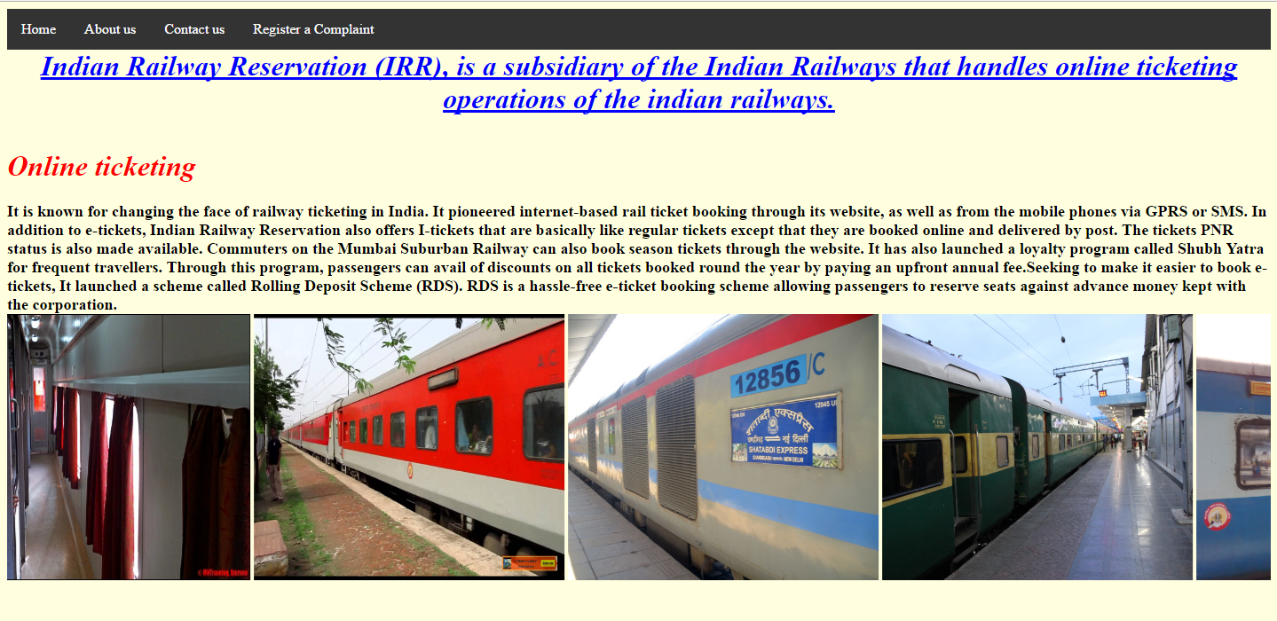

***Contact Us page:***

<html>

<head>

<title>Contact Us</title>

<style>

div.background {

background: url(c.jpg) repeat;

border: 2px solid black;

background-repeat:no-repeat;

background-size:1400px;

}

div.transbox {

margin: 30px;

background-color: #ffffff;

border: 5px solid black;

opacity: 0.9;

filter: alpha(opacity=60); /* For IE8 and earlier */

}

div.transbox p {

margin: 5%;

font-weight: bold;

color: #000000;

}

ul {

list-style-type: none;

margin: 0;

padding: 0;

overflow: hidden;

background-color: #333;

}

li {

float: left;

}

li a {

display: block;

color: white;

text-align: center;

padding: 14px 16px;

text-decoration: none;

}

li a:hover:not(.active) {

background-color: #111;

}

</style>

</head>

<body>

<ul>

<li><a href="file:///C:/Users/User/Desktop/train/109.html">Home</a></li>

<li><a href="file:///C:/Users/User/Desktop/train/about.html">About us</a></li>

<li><a href="file:///C:/Users/User/Desktop/train/contact.html">Contact us</a></li>

<li><a href="file:///C:/Users/User/Desktop/train/complaint.html">Register a Complaint</a></li>

</ul>

<h1><i>You may contact us</h1></i>

<div class="background">

<div class="transbox">

<b><font size="6">Customer Care No. : 011-39340000, 011-23340000 (language : Hindi and English)

Fax no. : 011-23345400.

<br><br>Registered Office / Corporate Office :

Indian Railway Reservation,

B-148, 11th Floor,Statesman House,

Barakhamba Road, New Delhi 110001.</b>

</font>

</div>

</div>

</body>

</html>

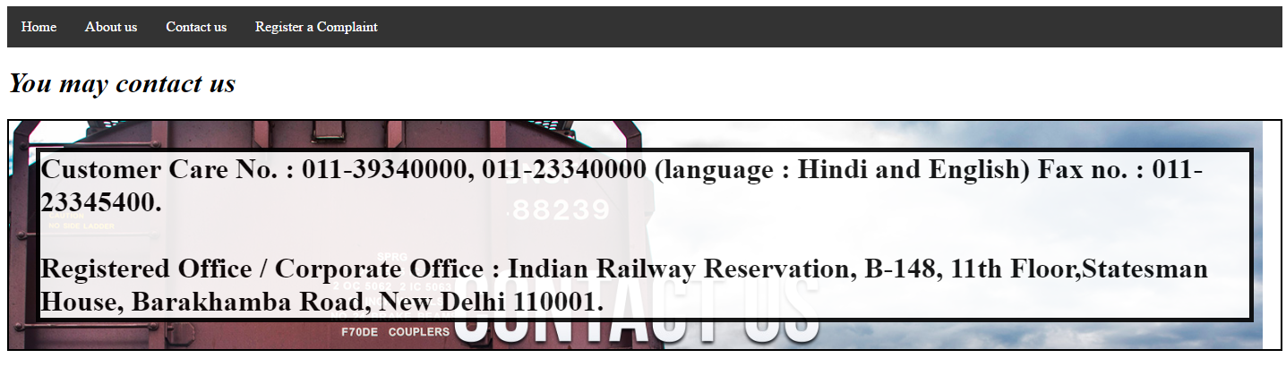

***Complaint page:***

<!DOCTYPE html>

<title>Complaint</title>

<style>

body{

background-image:url("co.jpg");

background-position:right top;

background-size: 2000px 900px;

background-repeat: no-repeat;

}

</style>

<body>

<form>

<center>

<nav>

<a href="file:///C:/Users/User/Desktop/train/109.html"><font size="5">Back to Home</font></a>

</nav>

<h1><i><u>Complaint description..... </u></i></h1>

<br>

Complaint:

<input type="text">

<br><br>

Incident Date:

<input type="date">

<br><br>

<h2><i><u>Reported by..... </i></u></h2>

<br><br>

Name:

<input type="text">

<br><br>

Contact no:

<input type="no" name="phone no" autocomplete="off" required maxlenght="10"><br><br>

Email id:

<input type="email" name="email" autocomplete="off" required>

<br><br>

<nav>

<a href="file:///C:/Users/User/Desktop/train/submitc.html"><font size="5"> Submit <br><br><input type="reset" value="Reset"></a></font>

</nav>

</center>

</form>

</body>

</html>

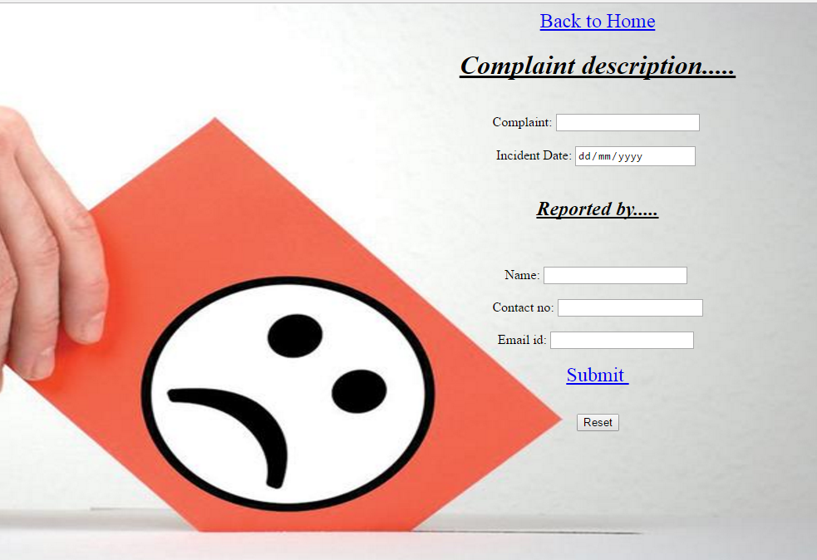

***After clicking on Submit:***

<!DOCTYPE html>

<title>Submit Complaint</title>

<body>

<nav>

<a href="file:///C:/Users/User/Desktop/train/109.html"><font size="5">Back to Home</font></a>

</nav>

<h1><b><i><center>You have registered your complaint....</center></i></b></h1>

</body>

</html>

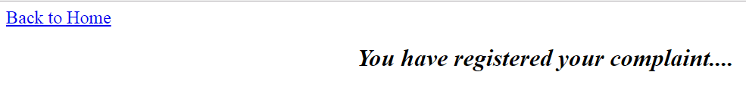

***Train time table (After clicking on login):***

<!DOCTYPE html>

<html>

<head>

<style>

body{

background-image: url("b.jpg");

background-repeat: repeat-x;

}

table {

width:100%;

}

table, th, td {

border: 3px solid black;

border-collapse: collapse;

}

th, td {

padding: 6px;

text-align: left;

}

table#t01 tr:nth-child(even) {

background-color: lightblue;

}

table#t01 tr:nth-child(odd) {

background-color:lightyellow;

}

table#t01 th {

background-color: black;

color:white;

}

</style>

</head>

<body>

<h1><i><b>Train Time Table</b></i></h1>

<table id="t01">

<tr>

<th>Train no</th>

<th>Train name</th>

<th>Source</th>

<th>Departure_Time</th>

<th>Destination</th>

<th>Arrival_Time</th>

</tr>

<tr>

<td>2057</td>

<td>LTT TEN PREMIUM</td>

<td>LokmanyaTilak T</td>

<td>13:20</td>

<td>Tiruneveli</td>

<td>22:00</td>

</tr>

<tr>

<td>2059</td>

<td>PUNE ERS PREMIUM</td>

<td>Pune JN</td>

<td>18:45</td>

<td>Ernakulam JN</td>

<td>20:05</td>

</tr>

<tr>

<td>2065</td>

<td>LTT ERS PREMIUM</td>

<td>LokmanyaTilak T</td>

<td>12:50</td>

<td>Ernakulam JN</td>

<td>14:00</td>

</tr>

<tr>

<td>2663</td>

<td>ADI HBJ PREMIUM</td>

<td>AHEMDABAD JN</td>

<td>17:30</td>

<td>Habibganj</td>

<td>05:00</td>

</tr>

<tr>

<td>2664</td>

<td>HBJ ADI PREMIUM</td>

<td>Habibganj</td>

<td>22:20</td>

<td>AHEMDABAD JN</td>

<td>09:15</td>

</tr>

<tr>

<td>2701</td>

<td>SC CSTM PREMIUM</td>

<td>SECUNDERABAD JN</td>

<td>23:05</td>

<td>MUMBAI CST</td>

<td>12:15</td>

</tr>

</table>

<br>

<nav>

<a href="file:///C:/Users/User/Desktop/train/login.html"><font size="5">Book</font></a>

</nav>

</body>

</html>

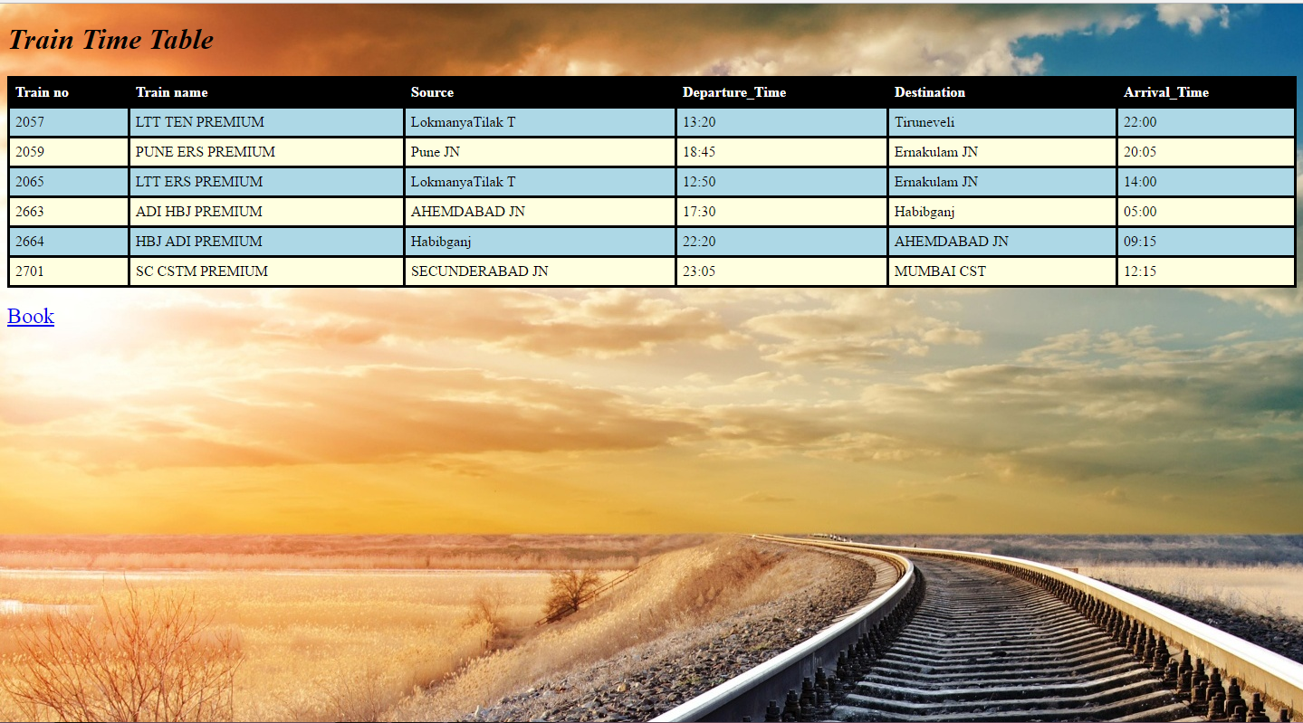

***Login page (After clicking on book):***

<!DOCTYPE html>

<title>Login</title>

<head>

<style>

p.double {border-style: double;}

body{

background-image: url("login.jpeg");

background-repeat: no-repeat;

background-position: right top;

background-size: 1000px 700px;

margin-right: 10px;

}

ul {

list-style-type: none;

margin: 0;

padding: 0;

overflow: hidden;

background-color: #333;

}

li {

float: left;

}

li a {

display: block;

color: white;

text-align: center;

padding: 14px 16px;

text-decoration: none;

}

li a:hover:not(.active) {

background-color: #111;

}

</style>

</head>

<body>

<ul>

<li><a href="file:///C:/Users/User/Desktop/train/109.html">Home</a></li>

<li><a href="file:///C:/Users/User/Desktop/train/about.html">About us</a></li>

<li><a href="file:///C:/Users/User/Desktop/train/contact.html">Contact us</a></li>

<li><a href="file:///C:/Users/User/Desktop/train/complaint.html">Register a Complaint</a></li>

</ul>

<h1><b><i><p class="double">Book your Train</h1></b></i></p>

<form>

Enter Source :

<input type="text" name="source">

<br><br>

Enter Destination :

<input type="text" name="destination">

<br><br>

Date of Departure :

<input type="date">

<br><br>

<p>Please input a number between 1 and 6:</p>

No of tickets :

<input id="numb">

<button type="button" onclick="myFunction()">Submit</button>

<p id="demo"></p>

<script>

function myFunction() {

var x, text;

// Get the value of the input field with id="numb"

x = document.getElementById("numb").value;

// If x is Not a Number or less than one or greater than 10

if (isNaN(x) || x < 1 || x > 6) {

text = "Input not valid";

} else {

text = "Input OK";

}

document.getElementById("demo").innerHTML = text;

}

</script>

<br>

Available trains :

<input list="trains" name="trains">

<datalist id="trains">

<option value="Rajdhani Express">

<option value="Karnavati Express">

<option value="Garibrath">

<option value="Golden Temple">

<option value="Loksati">

</datalist>

<br><br>

<nav>

<a href="file:///C:/Users/User/Desktop/train/booked.html"><font size="5">Book</font></a>

</nav>

</body>

</html>

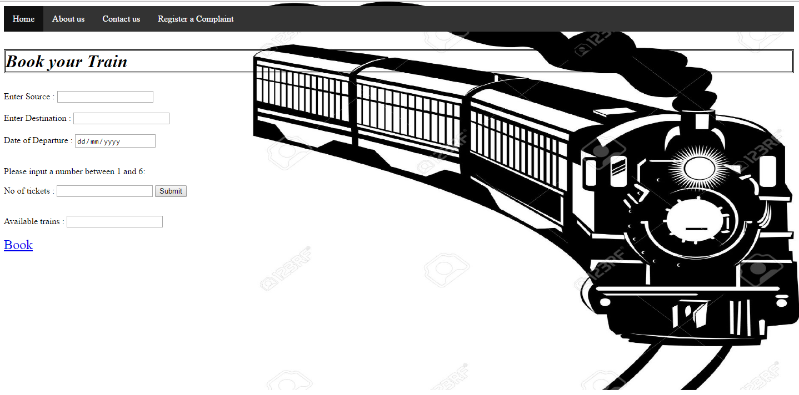

***After clicking on Book:***

<!DOCTYPE html>

<title>Booked</title>

<body>

<nav>

<a href="file:///C:/Users/User/Desktop/train/109.html"><font size="5">Back to Home</font></a>

</nav>

<h1><b><i><center>Your Seats have been booked....Thank you..</center></i></b></h1>

<center><img src="tyb.jpg" height="500px" ></center>

</body>

</html>

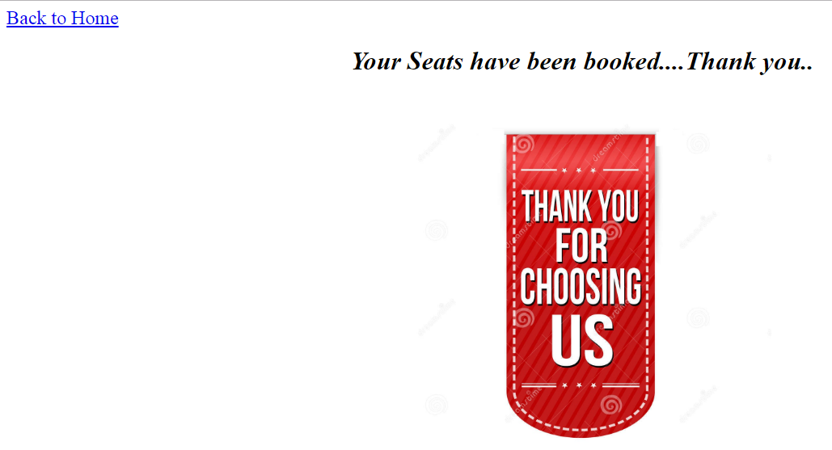

***On clicking Sign up button on Home page if not registered:***

<!DOCTYPE html>

<html>

<title>Registeration Form</title>

<head>

<style>

div.background {

background: url(train.jpg) repeat;

border: 2px solid black;

background-repeat:no-repeat;

background-size:1400px;

}

div.transbox {

margin: 30px;

background-color: #ffffff;

border: 1px solid black;

opacity: 0.6;

filter: alpha(opacity=60); /* For IE8 and earlier */

}

div.transbox p {

margin: 5%;

font-weight: bold;

color: #000000;

}

ul {

list-style-type: none;

margin: 0;

padding: 0;

overflow: hidden;

background-color: #333;

}

li {

float: left;

}

li a {

display: block;

color: white;

text-align: center;

padding: 14px 16px;

text-decoration: none;

}

li a:hover:not(.active) {

background-color: #111;

}

</style>

</head>

<body>

<ul>

<li><a href="file:///C:/Users/User/Desktop/train/109.html">Home</a></li>

<li><a href="file:///C:/Users/User/Desktop/train/about.html">About us</a></li>

<li><a href="file:///C:/Users/User/Desktop/train/contact.html">Contact us</a></li>

<li><a href="file:///C:/Users/User/Desktop/train/complaint.html">Register a Complaint</a></li>

</ul>

<div class="background">

<div class="transbox">

<h1><b><i>Registeration Form</i></b></h1>

<form>

First name :

<input type="text" name="firstname" placeholder="no numbers" autofocus>

<br><br>

Last name :

<input type="text" name="lastname" placeholder="no numbers">

<br><br>

E-mail :

<input type="email" name="email" autocomplete="off" required><br><br>

Phone no :

<input type="no" name="phone no" autocomplete="off" required maxlenght="10"><br><br>

Gender : <br>

<input type="radio" name="text" value="male"> Male<br>

<input type="radio" name="text" value="female"> Female<br>

<br><br>

Date of birth :

<input type="date">

<br><br>

Occupation

<input list="occupation" name="occupation">

<datalist id="occupation">

<option value="Government">

<option value="Public">

<option value="Private">

<option value="Professional">

<option value="Self Employed">

<option value="Student">

<option value="Other">

</datalist>

<br><br>

Address : <br>

<textarea rows="5" cols="100"></textarea>

<br><br>

User Id:

<input type="text" name="username" placeholder="atleast 6 characters" autofocus>

<br><br>

Password:

<input type="password" name="password" autofocus>

<br><br>

Confirm Password:

<input type="password" name="cpassword" autofocus>

<br><br>

<nav>

<a href="file:///C:/Users/User/Desktop/train/submit.html"><font size="5"> Submit <br><br><input type="reset" value="Reset"></a></font>

</nav>

<br>

</form>

</div>

</div>

</body>

</html>

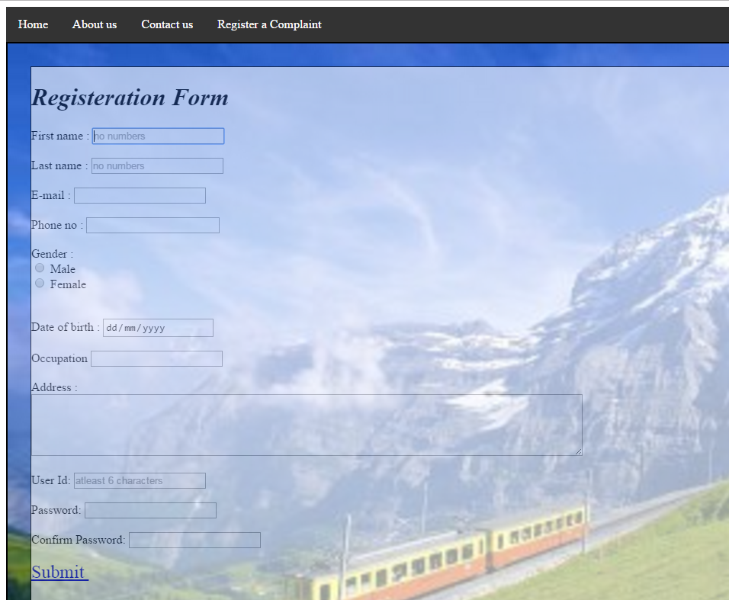

***After clicking on Submit:***

<!DOCTYPE html>

<title>Submit</title>

<body>

<nav>

<a href="file:///C:/Users/User/Desktop/train/109.html"><font size="5">Back to Home</font></a>

</nav>

<h1><b><i><center>You have successfully signed up....</center></i></b></h1>

<center><img src="ty.jpg"></center>

</body>

</html>

